
Introduction to Electrical Engineering
Lab Report
Name: Pranesh Chowdhury
ID: 202003112
Course ID: 112
Section: 2
Experiment No: 3
Experiment Name: Measurement of network equivalent resistance

Objective:
In this experiment we will measure the equivalent resistances. The circuits of the resistance are connected with the fundamental connections of resistors – series and parallel. We calculated the equivalent resistance by using resistance values of the individual resistors. This experiment aims to compare with the measure values and calculate value using the equation to calculate the resistances.
List of Equipment:
- Wires
- Resistors
- PSIM Software
- DC Power Supply
- Ammeters
Circuit Diagram:
1st Circuit:
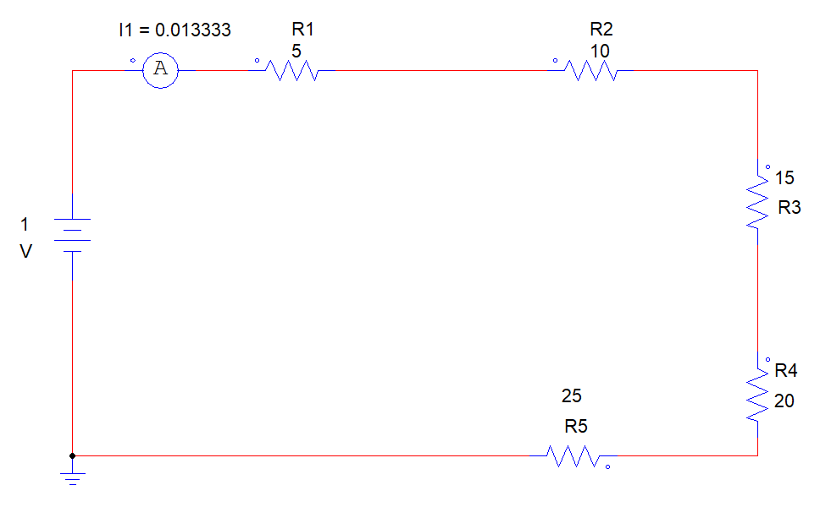

2nd Circuit:
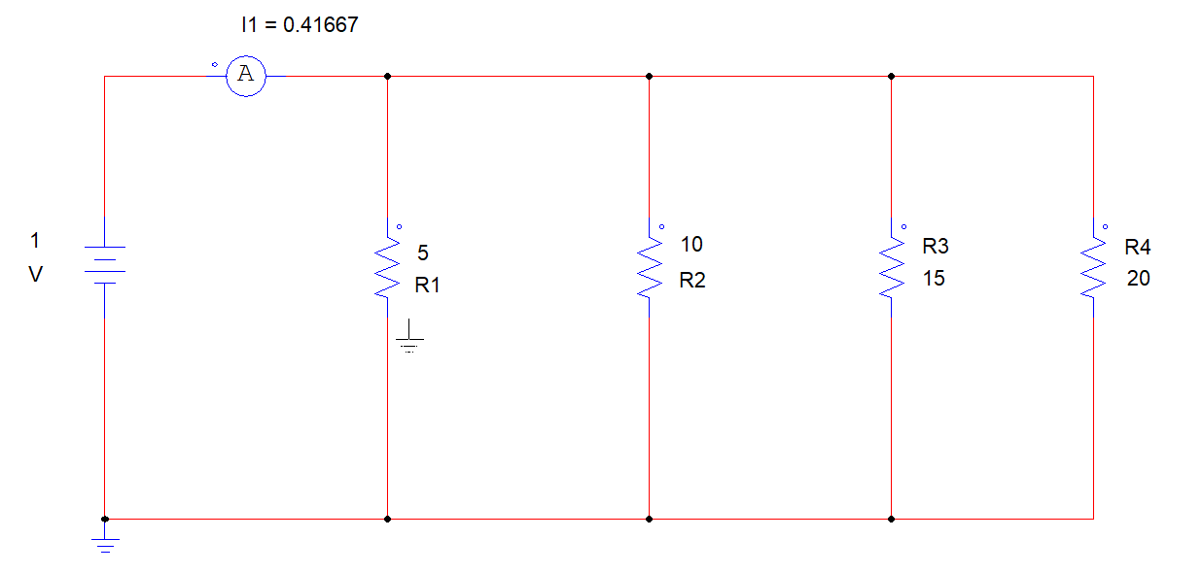
3rd Circuit:
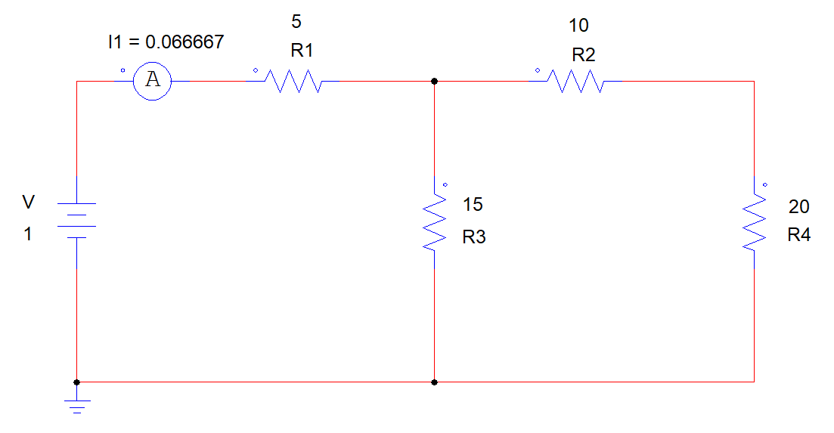
4th Circuit:
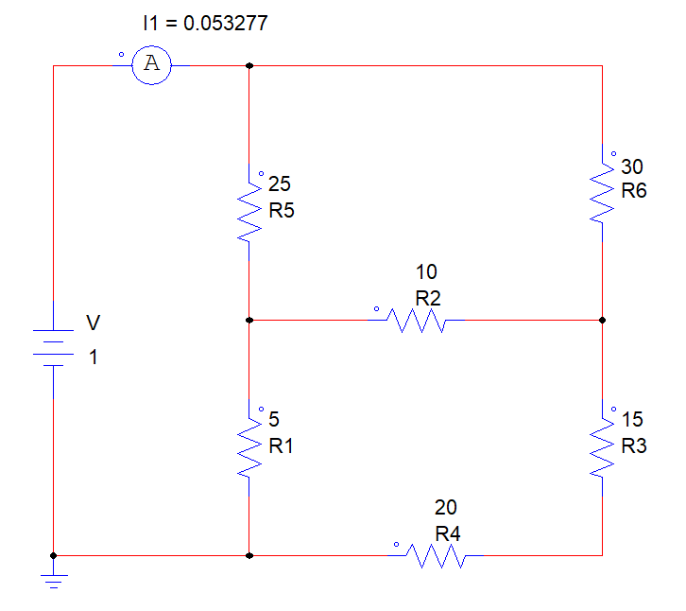
5th Circuit (Left):
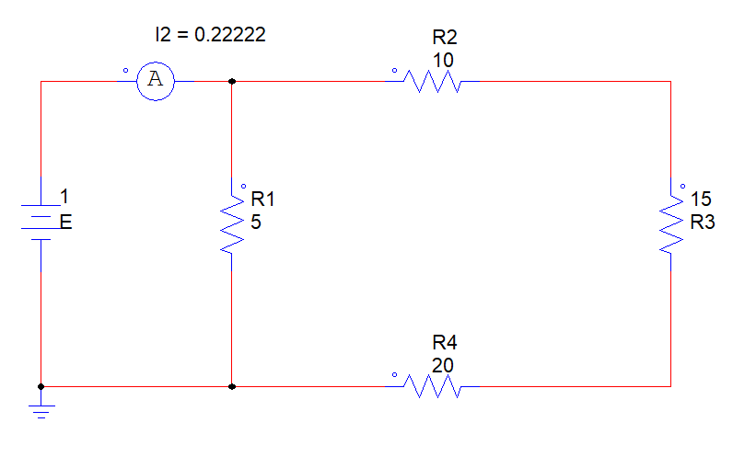
5th Circuit (Right):
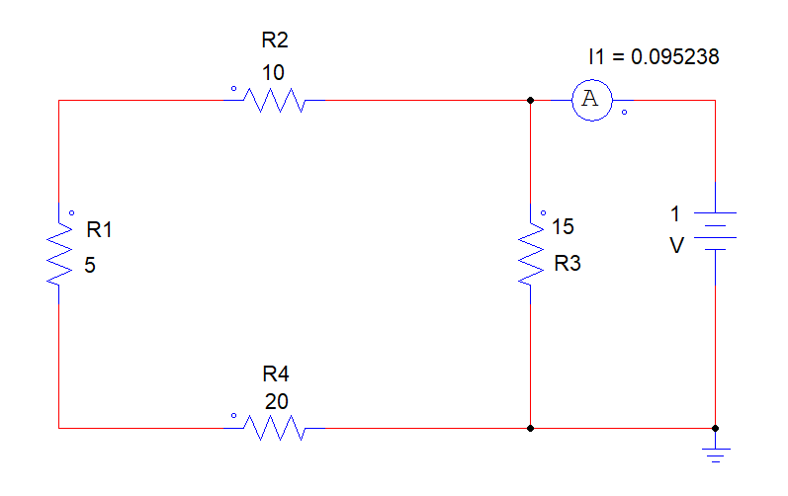
6th Circuit:
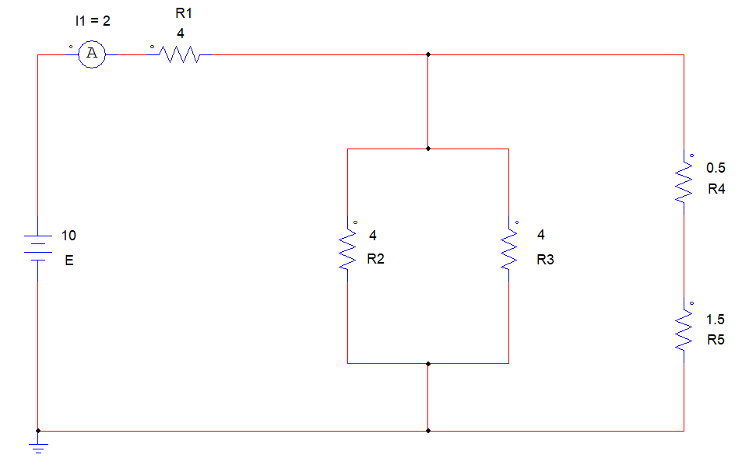
Result:
1st Circuit:
Measure Value:
- V = IR
- R = V / I
- R = 1 / 0.013333
- R = 75 Ohm’s
Calculate Value:
- Req = R1+R2+R3+R4+R5
- Req = 5+ 10+ 15+ 20+25 Ohm’s
- Req= 75 Ohm’s
2nd Circuit:
Measure Value:
- R = V/I
- R = 1/0.41667
- R = 2.4 Ohm’s
Calculate Value:
- 1/Req = 1/R1 + 1/R2 + 1/R3 + 1/R4
- Req = 2.4 Ohm’s
3rd Circuit:
Measure Value:
- R = V/I
- R = 1/ 0.066667
- R = 15 Ohm’s

Calculate Value:
- Req = {(R2 + R4) || R3} + R1
- Req= 15 Ohm’s

4th Circuit:
Measure Value:
- R = V/I
- R = 1/ 0.053277
- R = 18.77 Ohm’s
Calculate Value:
Ra= (R1 * R2+R1 * R5 + R2 * R5) / R2
- {5 * 10+ 5 * 25+ 10 * 25) / 10}
- 42.5 ohm’s
Rb= (R1*R2+ R1*R5+ R2*R5) / R5
- {(5*10 + 5*25 + 10*25) / 25}
- 17 ohm’s
Rc= (R1*R2 + R1* R5 + R2* R5) / R1
- {(5*10 + 5*25 + 10*25) / 5}
- 85 ohm’s
1/Rp1= 1/Rc + 1/ R6
- 1/Rp1= {(1/85) +(1/30)} Ohms
- Rp1= 22.174 Ohms
1/Rp2= 1/Rb + 1/(R3+R4)
- = { ( 1/17) + 1/(20+15) } Ohm’s
- Rp2= 11.442 Ohm’s
Rs= Rp1 + Rp2
- Rs= (22.174 + 11.442) Ohm’s
- Rs= 33.616 Ohm’s
1/Req= (1/Rs) + (1/Ra)
- Req= { (1/33.616) + (1/ 42.5)} Ohm’s
- Req= 0.053 Ohm’s
- Req= 18.77 Ohm’s

5th Circuit (Left):
Measure Value:
- R = V/I
- R = 1/0.22222
- R = 4.5 Ohm’s
Calculate Value:
- Req = (R2+R3+R4) || R1
- Req = (10+15+20) || 5
- Req = 4.5 Ohm’s
5th Circuit (Right):
Measure Value:
- R = V/I
- R= 1/0.095238
- R= 10.5 Ohm’s
Calculate Value:
- Req = (R2+R1+R4) || R3
- Req = (10+ 5 + 20) || 15
- Req = 10.5 Ohm’s
6th Circuit:
Measure Value:
- R = V/I
- R = 10/2
- R = 5 Ohm’s

Calculate Value:
- Req = {(R2 || R3) || (R4+R5)} + R1
- Req= { (10 || 15) || (20+25)} + 5
- Req= 5 Ohm’s

Data Table:
Measured Values |  |  |  | Calculate Values
R1 | 5 | Ckt1-RT | 75 Ohm’s | Ckt1-RT | 75 Ohm’s
R2 | 10 | Ckt2-RT | 2.4 Ohm’s | Ckt2-RT | 2.4 Ohm’s
R3 | 15 | Ckt3-RT | 15 Ohm’s | Ckt3-RT | 15 Ohm’s
R4 | 20 | Ckt4-RT | 18.7 Ohm’s | Ckt4-RT | 18.7 Ohm’s
R5 | 25 | Ckt5-RT(Left) | 4.5 Ohm’s | Ckt5-RT(Left) | 4.5 Ohm’s
R6 | 30 | Ckt5-RT(Right) | 10.5 Ohm’s | Ckt5-RT(Right) | 10.5 Ohm’s
 |  | Ckt6-RT | 5 Ohm’s | Ckt6-RT | 5 Ohm’s

Discussion:
In this experiment we measure the circuits and calculate the network resistance. We evaluate the six circuits using PSIM software. Measuring the values, using series and parallel and other resistance combination equations the values of resistance of the circuit’s values is equal to the measure value.

